🗄

Database Schema

Database Schema
Utility Billing System

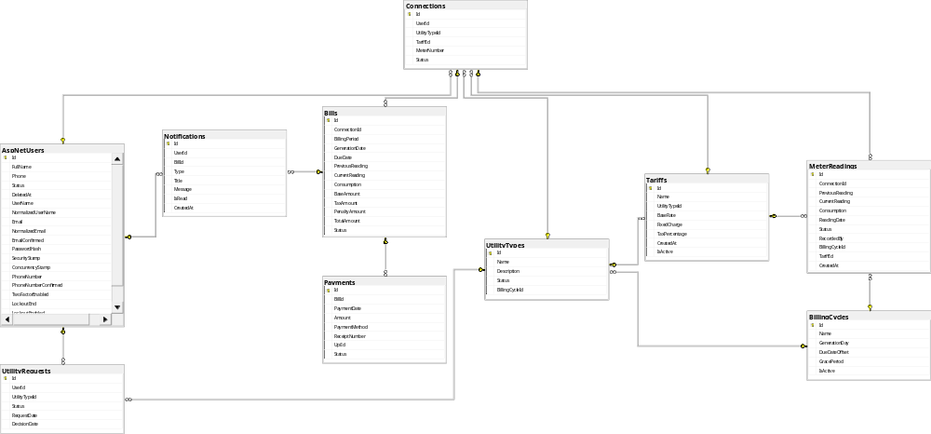
Database Schema Diagram

Table Definitions

AspNetUsers (User)
Base Table: Inherits from ASP.NET Core Identity
IdentityUser

Column Name | Data Type | Constraints | Description
Id | string (GUID) | PK | Primary key (inherited from IdentityUser)
UserName | string | Required, Unique | Username for login

Column Name | Data Type | Constraints | Description
Email | string | Required, Unique | Email address
EmailConfirmed | bool |  | Email confirmation status
PasswordHash | string |  | Hashed password
PhoneNumber | string |  | Phone number
PhoneNumberConfirmed | bool |  | Phone confirmation status
TwoFactorEnabled | bool |  | Two-factor authentication status
LockoutEnabled | bool |  | Account lockout status
AccessFailedCount | int |  | Failed login attempts
LockoutEnd | DateTimeOffset? |  | Lockout end time
FullName | string(200) | Required | Full name of the user
Status | string(20) | Default: "Active" | User status: Active, Inactive, Deleted
DeletedAt | DateTime? | Nullable | Soft delete timestamp

Navigation Properties:
* Collection of Connection entities
Connections
* Collection of UtilityRequest entities
UtilityRequests

UtilityType

Column Name | Data Type | Constraints | Description
Id | string (GUID) | PK | Primary key
Name | string(100) | Required | Name of the utility type (e.g., "Electricity", "Water")
Description | string(500) |  | Description of the utility type
Status | string(20) | Default: "Enabled" | Status: Enabled, Disabled
BillingCycleId | string (GUID) | FK, Nullable | Reference to BillingCycle

Navigation Properties:

* BillingCycle entity (nullable)
BillingCycle
* Collection of Tariff entities
Tariffs
* Collection of Connection entities
Connections
* Collection of UtilityRequest entities
UtilityRequests

BillingCycle

Column Name | Data Type | Constraints | Description
Id | string (GUID) | PK | Primary key
Name | string(200) | Required | Name of the billing cycle
GenerationDay | int | Required, Check: 1-  28 | Day of month when bills are generated
DueDateOffset | int | Required | Days after generation date for due date
GracePeriod | int | Required | Days after due date before penalty applies
IsActive | bool | Default: true | Whether the billing cycle is active

Navigation Properties:
* Collection of UtilityType entities
UtilityTypes

Constraints:
Check constraint:
GenerationDay BETWEEN 1 AND 28

Tariff

Column Name | Data Type | Constraints | Description
Id | string (GUID) | PK | Primary key
Name | string(200) | Required | Name of the tariff plan
UtilityTypeId | string (GUID) | FK, Required | Reference to UtilityType
BaseRate | decimal(18,2) | Required, Range: 0 | Rate per unit of consumption

Column Name | Data Type | Constraints | Description
FixedCharge | decimal(18,2) | Required, Range: 0 | Monthly fixed charge
TaxPercentage | decimal(5,2) | Required, Range: 0-100 | Tax percentage applied
CreatedAt | DateTime | Required, Default: UtcNow | Creation timestamp
IsActive | bool | Default: true | Whether the tariff is active

Navigation Properties:
* UtilityType entity
UtilityType
* Collection of Connection entities
Connections

Connection

Column Name | Data Type | Constraints | Description
Id | string (GUID) | PK | Primary key
UserId | string (GUID) | FK, Required | Reference to User (AspNetUsers)
UtilityTypeId | string (GUID) | FK, Required | Reference to UtilityType
TariffId | string (GUID) | FK, Required | Reference to Tariff
MeterNumber | string(50) | Required, Unique | Unique meter number
Status | string(20) | Default: "Active" | Status: Active, Inactive

Navigation Properties:
  - User entity
User
    - UtilityType entity
UtilityType
  - Tariff entity
Tariff
* Collection of Bill entities
Bills

Indexes:
Unique index on
MeterNumber

UtilityRequest

Column Name | Data Type | Constraints | Description
Id | string (GUID) | PK | Primary key
UserId | string (GUID) | FK, Required | Reference to User
UtilityTypeId | string (GUID) | FK, Required | Reference to UtilityType
Status | string(20) | Default: "Pending" | Status: Pending, Approved, Rejected
RequestDate | DateTime | Required, Default: UtcNow | Date when request was made
DecisionDate | DateTime? | Nullable | Date when request was approved/rejected

Navigation Properties:
  - User entity
User
    - UtilityType entity
UtilityType

MeterReading

Column Name | Data Type | Constraints | Description
Id | string (GUID) | PK | Primary key
ConnectionId | string (GUID) | FK, Required | Reference to Connection
PreviousReading | decimal(18,2) | Range: 0 | Previous meter reading value
CurrentReading | decimal(18,2) | Range: 0 | Current meter reading value
Consumption | decimal(18,2) | Range: 0 | Calculated consumption (Current - Previous)
ReadingDate | DateTime | Required | Date when reading was taken
Status | string(20) | Default:  "ReadyForBilling" | Status: ReadyForBilling, Billed
RecordedBy | string(200) | Required | User who recorded the reading
BillingCycleId | string (GUID) | FK, Nullable | Reference to BillingCycle
TariffId | string (GUID) | FK, Required | Reference to Tariff (snapshot at reading time)

Column Name | Data Type | Constraints | Description
CreatedAt | DateTime | Required, Default: UtcNow | Creation timestamp

Navigation Properties:
  - Connection entity
Connection
  - BillingCycle entity (nullable)
BillingCycle
* Tariff entity
Tariff

Indexes:
Unique composite index on

with filter
(ConnectionId, BillingCycleId)
Status =

'ReadyForBilling'
Index on Index on
ReadingDate
Status
- Bill

Column Name | Data Type | Constraints | Description
Id | string (GUID) | PK | Primary key
ConnectionId | string (GUID) | FK, Required | Reference to

